**EDS Activity 1**

Name: Utkkarsh Deshpande

PRN no.: 202401100044

Roll no.: CS5-09

Batch: C51

Importing the datasheet:



Q1 How many matches were played in each season?

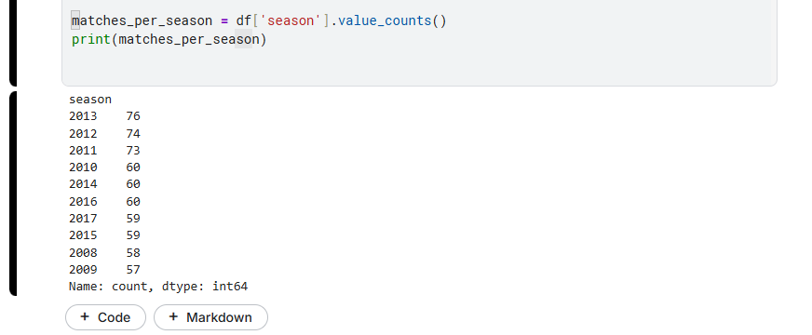

Q2 How many matches were played in each city?

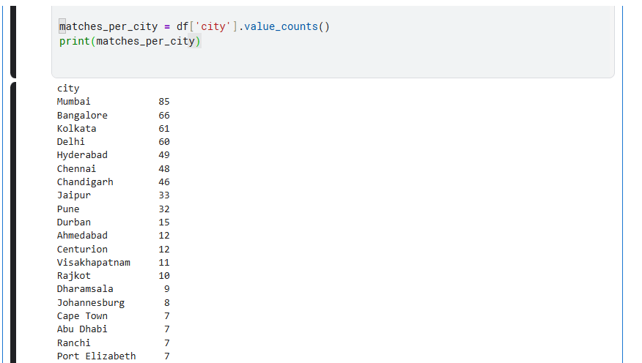

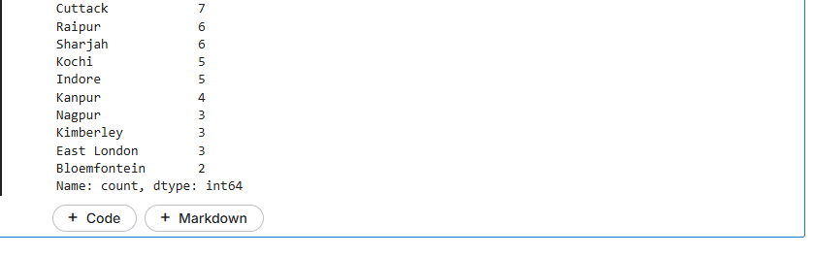

Q3 Which team has won the most tosses?

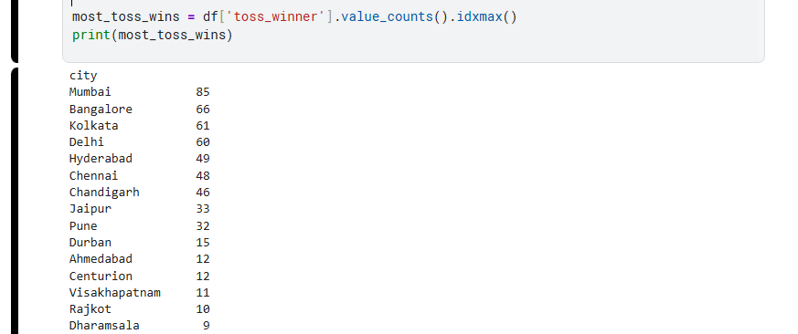

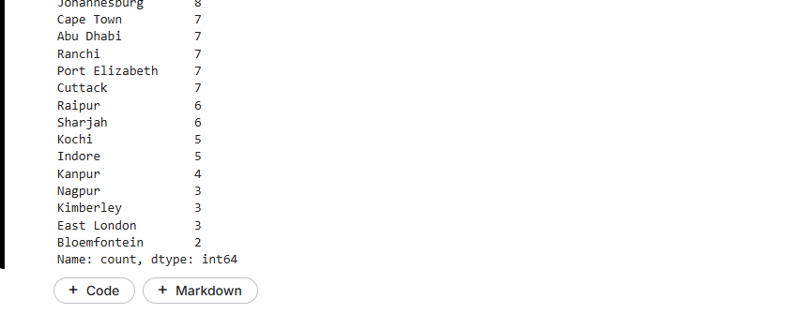

Q4 Which team has won the most matches?

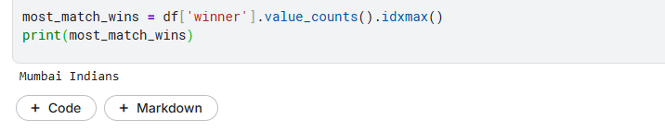

Q5 Find the player with the most "Player of the Match" awards.

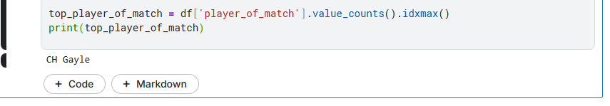

Q6 How many matches had a result decided by D/L method?

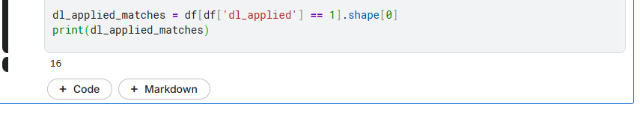

Q7 What is the highest "win_by_runs" recorded?

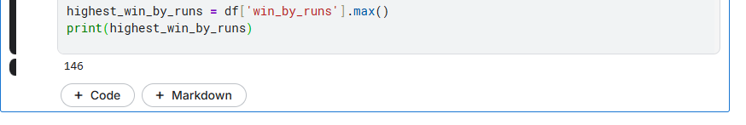

Q8 What is the highest "win_by_wickets" recorded?

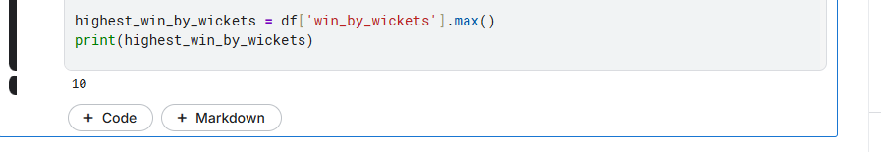

Q9 How many matches ended with no result?

Q10 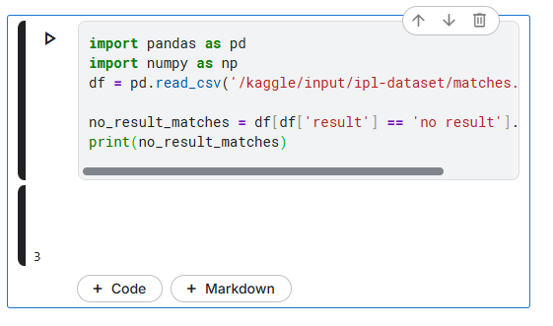

Find the most common venue where matches were played.

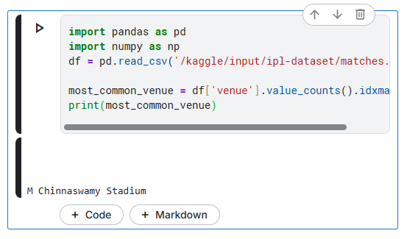

Q11 Find the team winning most matches after choosing to field.

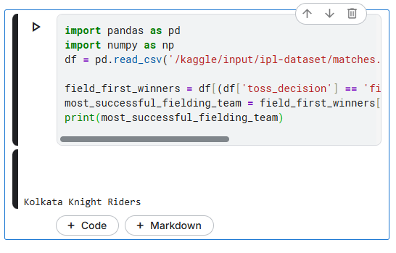

Q12 Calculate the win percentage of each team.

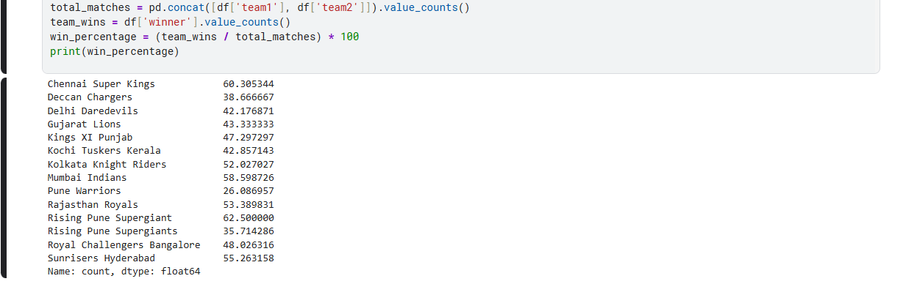

Q13 List the top 5 players who received the most "Player of the Match" awards in a single season.

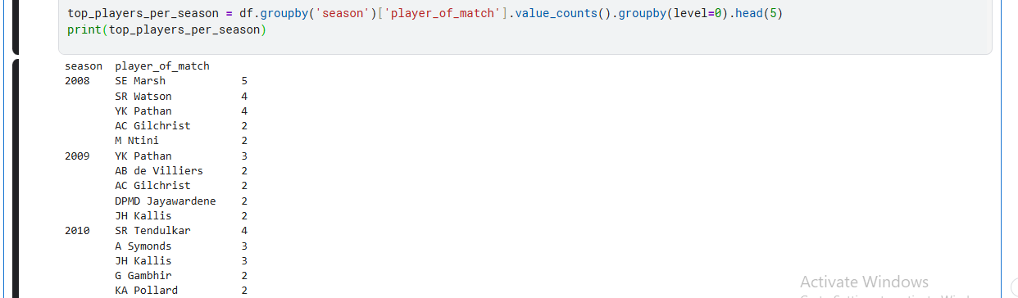

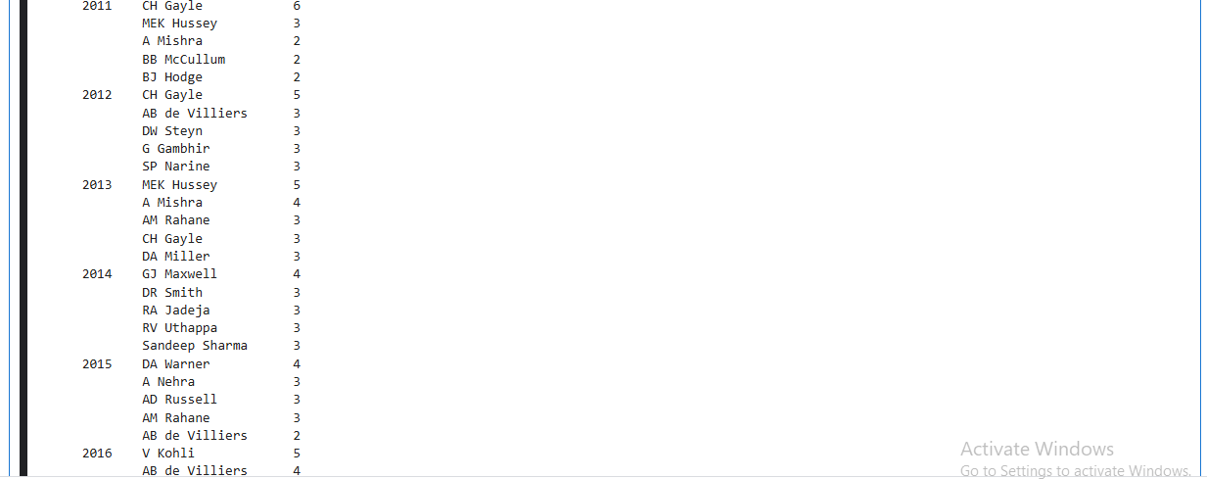

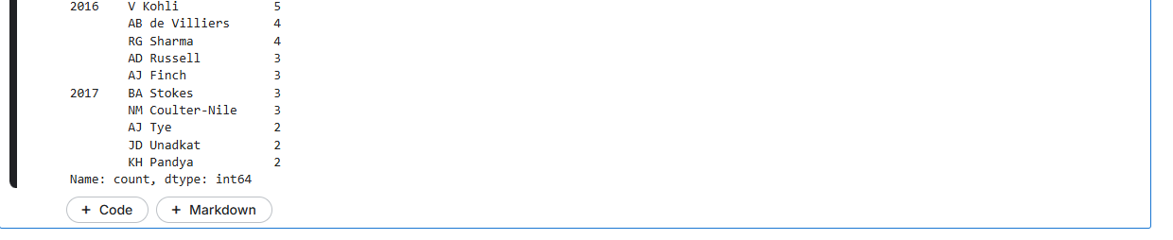

Q14 Identify the most successful umpire (appeared most often).

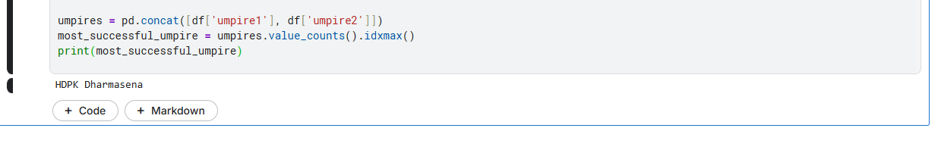

Q15 Number of matches played by each team.

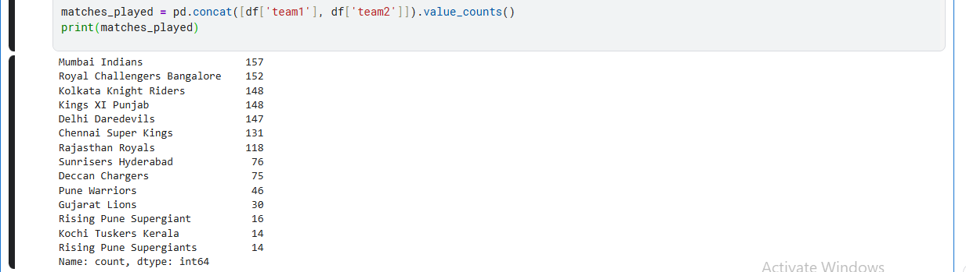

Q16 Teams that have defended a score successfully most times.

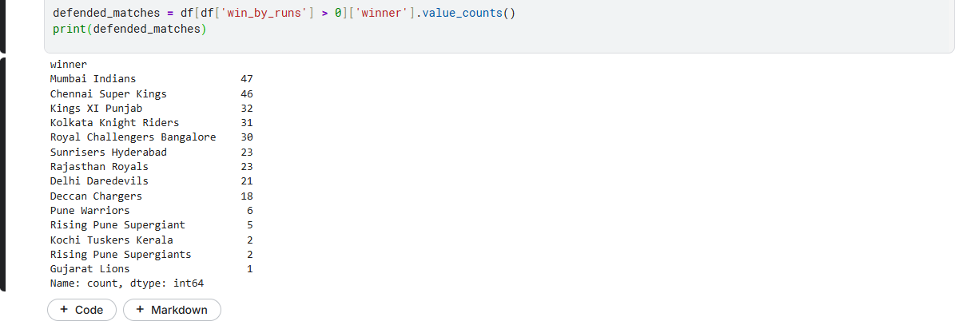

Q17 Average margin of victory by runs when batting first.

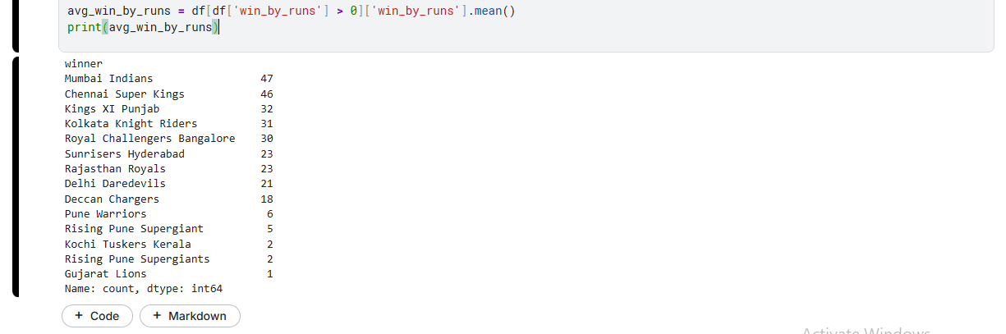

Q18 Average margin of victory by wickets when chasing.

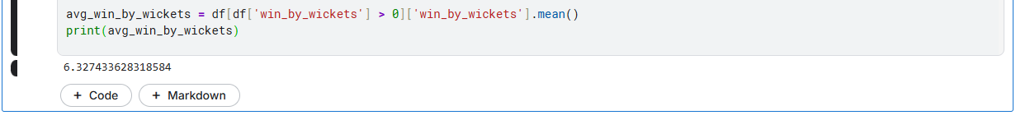

Q19 In which season was the maximum number of matches played?

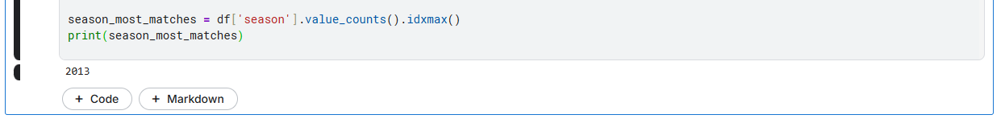

Q20 How many matches had the toss winner also win the match?

